Craig Plazony

ECE 505

Deliverable 3

1. Is one fuel better than the other for the purposes of Average Miles Per Gallon?

H0 – The means of each biofuels Average Miles Per Gallon (AMPG) are the same.

The assumptions I am making for this are that the Idle times are not different between the two groups. Most of that data is missing and is the same for data that does exist. I also assume these trucks are similar make/model and took the same routes on average.

To determine if H0 is not rejected, I will be using paired two-sample t-test with a confidence level of 95%. We get the following results

|  |  |
| --- | --- |
| T Value | -.363 |
| P Value | .720 |
| Degrees of Freedom | 22 |

Table Independent two-sample t-test results

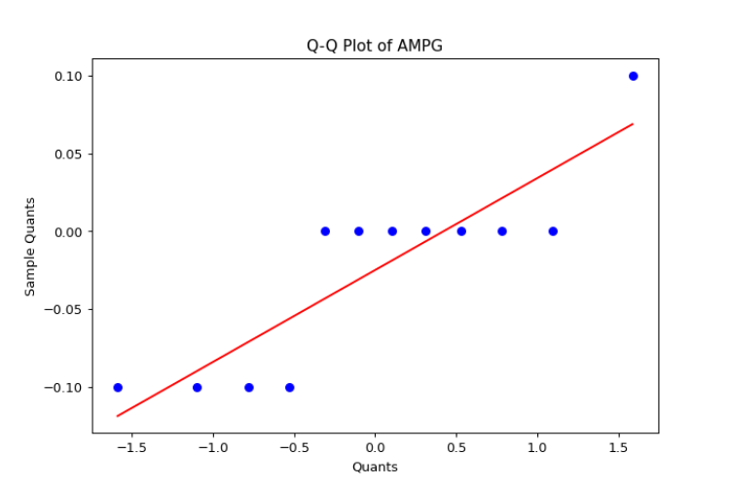

Figure Q-Q plots for both biofuel AMPG

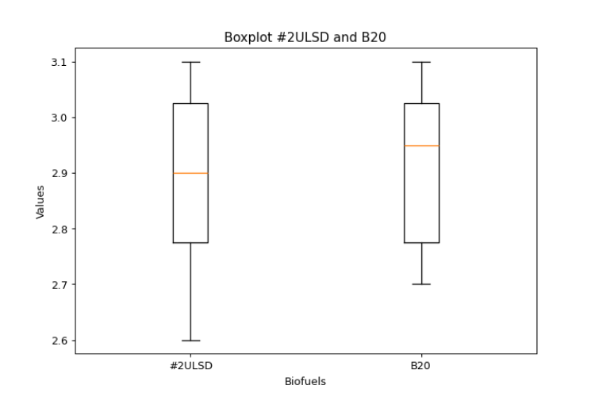

Figure Boxplot of the AMPG of the two biofuels

The p-value is much higher than .05 but the distributed difference between them is not normally distributed. If you look at the Boxplots, you see they are very similar to each other. From this, we can see that H0 is not rejected. This means there is no evidence that suggest a significant difference between the two AMPG.

1. Is one fuel better than the other for the purposes of particulate emissions in their exhaust?

H0 – the difference between the total particulate emissions of the biofuels is the same.

The assumption I am making for this is that similar trucks were tested for each fuel as indicated by the data labeling trucks 1 and 1b. I will compare each particulate type to each other per fuel.

To determine if H0 is not rejected, I will be using paired two-sample t-test with a confidence level of 95%. We get the following results

|  |  |  |
| --- | --- | --- |
| Particulate | t-statistic | p-value |
| Iron | 0.3681 | 0.7135 |
| Lead | -3.4290 | 0.0011 |
| Copper | -0.4679 | 0.6409 |
| Chro | 1.5122 | 0.1337 |
| Aluminum | 0.1579 | 0.8748 |
| Silicon | 1.4654 | 0.1479 |
| Sodium | 1.7986 | 0.0772 |
| Potassium | 1.9239 | 0.0584 |

Table Independent two-sample t-test results for each particulate in the biofuel exhaust

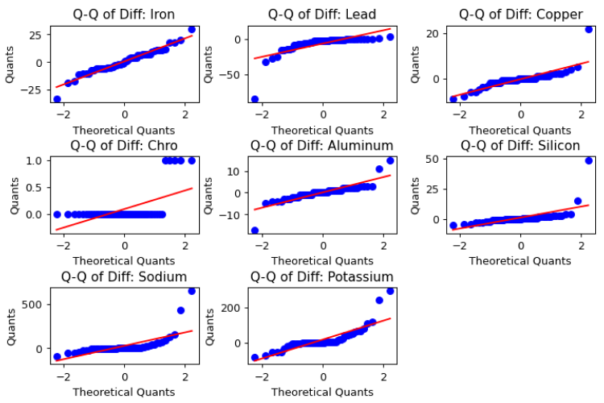

Figure QQ Difference plots for each particulate to determine normality

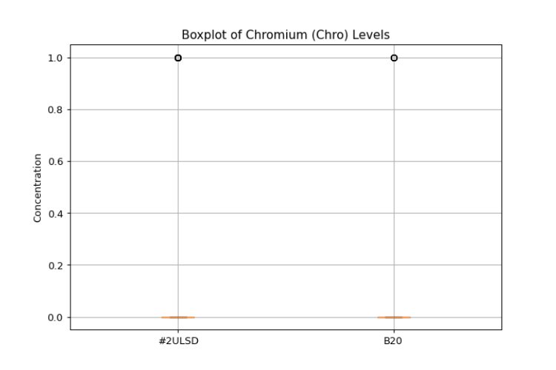

Figure Boxplot of Chromium concentration for both Biofuels.

The p-values are higher than .05 in all but Lead. All of them appear to be normally distributed except for Chromium. But, based on the Boxplot, you can see that their means are almost the same because a vast majority of the data is 0. From this, we can say that H0 is not rejected for everything except Lead. This means there is no evidence that suggests a significant difference between the two Particulates except for Lead concentrations which is Higher in B20.

3. Are there relationships between base/acid levels and the particulate in the exhaust?

H0 – The is no relation between the particulate amount and the Total Acid Number (TAN) and Total Basse Number (TBN) of a biofuel.

The assumption that I am making is that there is not a significant oil difference between the trucks. Because of the findings above, I will be removing Chromium from the rest of the tests. I will compare the TAN/TBN to each particulate to see if they go up or down base on either using a Linear Regression model.

|  |  |  |  |  |
| --- | --- | --- | --- | --- |
| TAN |  |  |  |  |
| Particulate | P-Value | F-Stat | Slope * x + Intercept | Strength of Relationship |
| Iron | 0.0511 | 3.890 | 1.7838x + 16.0723 | Borderline but Evidence |
| Lead | ~0 | 19.96 | 2.9879x + -9.8512 | Evidence |
| Copper | 0.247 | 1.355 | -0.3722x + 4.8861 | None |
| Aluminum | 0.279 | 1.183 | 0.2985x + 5.3066 | None |
| Silicon | 0.254 | 1.317 | -0.5597x + 7.8205 | None |
| Sodium | 0.354 | 0.8679 | -6.8017x + 49.6128 | None |
| Potassium | 0.116 | 2.514 | -6.3585x + 42.0483 | None |
| **TBN** |  |  |  |  |
| Iron | ~0 | 27.01 | -4.0968x + 47.94 | Evidence |
| Lead | ~0 | 41.27 | -5.0821x + 36.0616 | Evidence |
| Copper | 0.666 | 0.1873 | 0.1331x + 2.7221 | None |
| Aluminum | 0.979 | ~0 | 0.007x + 6.3351 | None |
| Silicon | 0.381 | 0.7724 | -0.4110x + 8.3658 | None |
| Sodium | 0.187 | 1.767 | 9.2467x - 32.2938 | None |
| Potassium | 0.0416 | 4.253 | 7.8510x - 29.59 | Borderline but Evidence |

Table 3 Linear Regression model analysis of particulate amount affecting TAN and TBN

We can conclude that the Lead has some relationship with both. Iron has a strong relationship with TBN but weak with TAN. But, because it is so related to TBN, it probably is related to TAN. Potassium is a little bit unclear if there is any relationship, but if there is one it would be weak for TBN at least. Everything else H0 is not rejected and there is no evidence of association.